# Alexandria: A Single-Cell RNA-Seq and Analytics Platform for Global Health



Work-in-progress documentation for the Alexandria platform and all associated tool workflows.

The first tool Alexandria offers is the dropseq_scCloud, a workflow that joins the functionalities of [Drop-seq pipeline](http://mccarrolllab.org/dropseq/) with [scCloud](https://sccloudpy.readthedocs.io/en/latest/).

### Background

Single-cell genomic profiling approaches are transforming basic and applied biological inquiry. These methods—and, in particular single-cell RNA-Seq (scRNA-Seq)—enable powerful, general frameworks for identifying cell types/states, circuits, and biomarkers by explicitly measuring single-cell properties (e.g., gene expression), rather than just the mean of a population of unknown complexity, as well as their co-variation across single cells. The exciting possibility of realizing unbiased “atomic” resolution cellular maps of biological specimens with scRNA-Seq has spurred efforts by the broader scientific community to begin formally constructing a Human Cell Atlas (HCA) as an essential resource for the community2. Unfortunately for the global health community, initial HCA efforts will focus on healthy human tissues alone. While the pipelines used by the HCA to preprocess data will be open source, a distinct effort is needed to bring their transformative potential to bear on datasets of relevance to global health. Moreover, as many global health studies rely on model organisms, such as non-human primates (NHP; e.g., Cynomolgus or Rhesus) or rodents (e.g., mice, rats, guinea pigs), where perturbation studies (e.g., challenge or vaccination) are more feasible and ethical, and more controlled experiments can be performed, similar approaches need to be available to analyze these datasets. Further, new integrative analytic pipelines and visualization, currently outside of the scope of HCA, need to be established to enable efficient comparisons across datasets, species, and diseases to facilitate rapid in silico hypothesis testing and the prioritization of follow-up experiments. Equally importantly, a dedicated front-end portal is needed to facilitate globally access and querying of these data resources to allow data inspection by all who have domain expertise and the potential to contribute.

Here, we propose to realize these goals via “Alexandria” – a single-cell portal and data resource for the global health community. Alexandria will use unified HCA pipelines to preprocess, store, and visualize datasets of interest to the global health community, enabling rapid realization of transformative insights and the prioritization of follow-ups. To maximize impact and utility, Alexandria will build upon existing efforts at the Broad which leverage HCA pipelines—namely Single Cell Portal—but will be further enhanced to enable queries across gene sets, cell types, and models as inspired by the types of data collected by the global health community. This will power vital cross-comparisons while simultaneously providing novel analytic capabilities for HCA community at large. Moreover, Alexandra will similarly empower the broader global research community—from individuals with limited experience in single-cell analysis to power users looking to more rapidly isolate specific subsets of data from several experiments—to examine and parse scRNA-Seq data, so that the insights and intuitions of the entire scientific community can be leveraged to enable rapid progress in fighting a variety of human maladies.

## Formatting Your input_csv_file

The input CSV file is a user-written comma-separated values (.csv) file with column headers and contains the following in whatever order:

* **(REQUIRED)** the ‘Sample’ column, the sample names that prefix the respective .fastq.gz files/BCL directories and the count matrices outputted by Drop-seq pipeline.
* (OPTIONAL) both ‘R1_Path’ and ‘R2_Path’ columns, the paths to fastq.gz files on the bucket. If these columns are not included or if some spreadsheet cells under these columns are left blank, the workflow will check dropseq_default_directory by default for unspecified files.
* (OPTIONAL) ‘BCL_Path’ column, the paths to the BCL directories on the bucket. If not included or if cells are left blank, will check dropseq_default_directory by default.
* (OPTIONAL) Other metadata columns that will be appended to the alexandria_metadata.txt (tab-delimited) file generated after running scCloud. Column labels MUST match the names of the ATTRIBUTE list in the [Alexandria Metadata Convention](https://github.com/ShalekLab/alexandria/blob/master/Docker/metadata_type_map.tsv). Labels outside of this convention will be supported in the future

If made in a spreadsheet manipulation program such as Microsoft Excel, make sure to save your file as a .csv file. 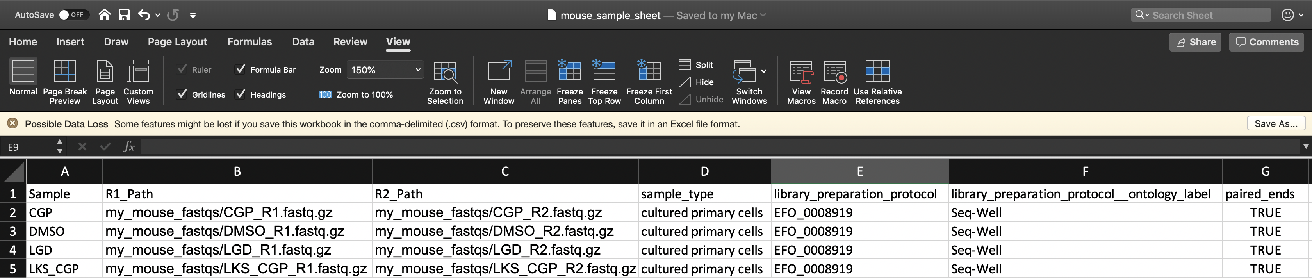

#### Understanding dropseq_default_directory

The use of this variable is not essential and is only meant to help users write their CSV faster. If the snapshot you are using requires dropseq_default_directory and you do not wish to use it, just enter an empty string: "".

Refer to the above spreadsheet example. There are four samples which each have two FASTQ reads. All FASTQ files are found in a folder located at the root of the bucket called mouse_fastqs. Since they are all located in the same directory, one could set mouse_fastqs as the dropseq_default_directory and no longer need to have R1_Path and R2_Path columns. 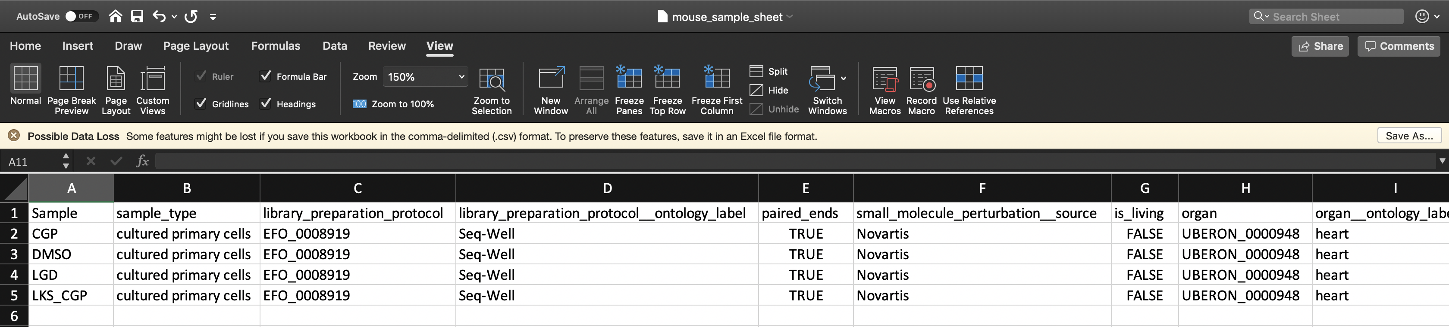

If the user has R1_Path and R2_Path columns but leaves spreadsheet cells left blank, the pipeline will search in the dropseq_default_directory for the corresponding sample 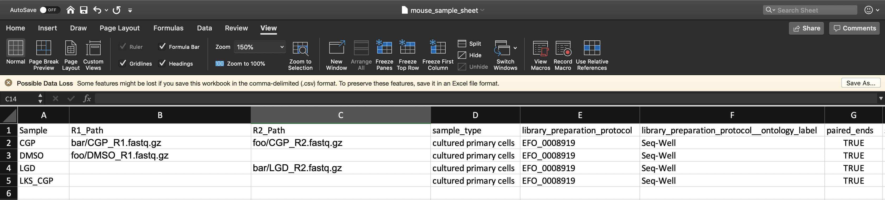 Here the pipeline will search the gs://[bucket ID]/mouse_fastqs directory for any spreadsheet cells left blank; DMSO_R2.fastq.gz, LGD_R1.fastq.gz, LKS_CGP_R1.fastq.gz, and LKS_CGP_R2.fastq.gz. The specific pattern the pipeline searches for is “[Sample Name]*[R1 or R2]*.fastq.gz”.

## Inputs of the dropseq_scCloud Workflow

#### Basic Usage

|  |  |  |
| --- | --- | --- |
| **Variable** | **Description** | **Exposed on SCP** |
| bucket | gsURL of the workspace bucket to which you have permissions, ex: gs://fc-e0000000-0000-0000-0000-000000000000/. SCP locks this value to be the workspace bucket. | No |
| input_csv_file | The spreadsheet (comma-separated value file) uploaded in the miscellaneous tab of your study’s Upload/Edit Study Data page. **Formatting must adhere to the criteria!** | Yes |
| reference | Enter the name of the genome to which you wish to align. Supported options include hg19, mm10, hg19_mm10, or mmul_8.0.1. Custom json references and hg38 will be supported in the future. | Yes |
| run_dropseq | Select Yes to run the [Drop-seq pipeline workflow](https://sccloud.readthedocs.io/en/latest/drop_seq.html) which will align your sequencing data and perform quality control. | Yes |
| (OPTIONAL in 75 or default=False) is_bcl | Select Yes if all of your data is in BCL format, [bcl2fastq](https://support.illumina.com/content/dam/illumina-support/documents/documentation/software_documentation/bcl2fastq/bcl2fastq_letterbooklet_15038058brpmi.pdf) will be run to convert your data to fastq.gz. Select No if all of your data is of fastq.gz type. | Yes |
| (OPTIONAL in 75) dropseq_default_directory | If all of your sequence data are located within the same folder on your bucket, enter the path to that folder starting from the bucket. Ex: Enter data/mouse_fastqs for folder mouse_fastqs located at the following gsURL: gs://[bucket ID]/data/mouse_fastqs/. If not applicable, view the documentation to learn how you can list paths in the input_CSV_file. | Yes |
| dropseq_output_directory | Enter the path leading to a bucket folder where you wish all of the Drop-seq outputs (aligned data, count matrices, etc.) to be stored. All folders in this path will be created if they do not exist. Ex: Entering data/20190916/aligned will store all Drop-seq outputted files at gsURL gs://[bucketID]/data/20190916/aligned/ | Yes |
| run_scCloud | Select Yes if you wish to create run the [scCloud workflow](https://sccloud.readthedocs.io/en/latest/scCloud.html) which will generate metadata, cluster files, coordinate files to be uploaded into the Alexandria for exploration. | Yes |
| scCloud_output_directory | Enter the path leading to a bucket folder where you wish all of the scCloud outputs (expression matrix, metadata, cluster, and coordinate files) to be stored. All folders in this path will be created if they do not exist. Ex: Entering data/20190916/analysis will store all Drop-seq outputted files at gsURL gs://[bucketID]/data/20190916/analysis/ | Yes |

#### Advanced Usage

|  |  |  |
| --- | --- | --- |
| **Variable** | **Description** | **Exposed on SCP** |
| preemptible, default=2 | Number of request attempts made for a preemptible virtual machine instance before requesting a higher-cost, faster, non-preemptible instance. See [this Google Cloud documentation page](https://cloud.google.com/preemptible-vms/) for details. | Yes |
| zones, default=“us-east1-d us-west1-a us-west1-b” | The ordered list of zone preferences for requesting a Google machine to run the pipeline. See [this Google Cloud documentation page](https://cloud.google.com/compute/docs/regions-zones/) for details. | Yes |
| scCloud_output_prefix, default=“sco” | Enter a name you may wish to prefix to your outputted scCloud files so that you can differentiate them from files from a different job. | Yes |
| alexandria_version, default=“0.1” | Version tag of the [shaleklab/alexandria](https://hub.docker.com/r/shaleklab/alexandria/tags) dockerfile to use. | Yes |
| dropseq_tools_version, default=“2.3.0” | Version of the [regevlab/dropseq](https://hub.docker.com/r/regevlab/dropseq/tags) dockerfile to use for the respective version of dropseq-tools. | Yes |
| scCloud_version, default=“0.8.0:v1.0” | Version of the [regevlab/](https://hub.docker.com/u/regevlab)sccloud dockerfile to use for the respective version of scCloud. | Yes |

#### Drop-seq Pipeline and scCloud Optional Inputs Exposed on Terra

See the [Drop-seq Pipeline workflow documentation](https://sccloud.readthedocs.io/en/latest/drop_seq.html#inputs).  
*NOTE: dropEst does not account for strandedness and therefore its usage is not recommended.* *NOTE:

See the [scCloud workflow documentation](https://sccloud.readthedocs.io/en/latest/scCloud.html#aggregate-matrix).

## Outputs of the dropseq_scCloud workflow

When running dropseq and/or scCloud through dropseq_scCloud, the workflow yields the same outputs as their counterparts.

Explicitly, dropseq_scCloud_workflow presents the Single-Cell Portal with the alexandria metadata file (alexandria_metadata.txt), the dense expression matrix (ends with .scp.expr.txt), and the two coordinate files (end with .scp.X_diffmap_pca.coords.txt and .scp.X_fitsne.coords.txt).

# 

# Running dropseq_scCloud on Alexandria

The Alexandria portal is hosted on the Broad Institute’s Single Cell Portal (SCP), therefore running the workflow here is identical to running it on SCP.

The Alexandria workflow version of dropseq_scCloud is intended as a user-accessible means of analyzing and visualizing single-cell RNA data. Therefore, only essential parameters are exposed.

Those who would like more options for running the workflow should use the Terra version of the workflow and then transfer/sync the outputs to your Alexandria workspace study bucket.

If you truly would like certain parameters to be exposed, please contact jgatter@broadinstitute.org.

### KNOWN BUGS IN v7:

* Do not upload sequence files into the root of the bucket, instead use gsutil to move them into a folder on your bucket. Example: gsutil -m cp -r local/mouse_fastqs gs://[bucket ID]/mouse_fastqs. gsutil -m mv gs://[bucket ID]/*.fastq.gz gs://[bucket ID]/mouse_fastqs can be used to move all FASTQs already on the bucket to a directory mouse_fastqs that will be automatically created.
* is_bcl=true/run_bcl2fastq=true is broken due to regevlab changing their docker repo for the tool.

### 1. Sign In

Visit the [Alexandria](https://singlecell.broadinstitute.org/single_cell?scpbr=the-alexandria-project) and at the top-right click “Sign In”. Sign in using your broadinstitute.org email account and allow permissions. 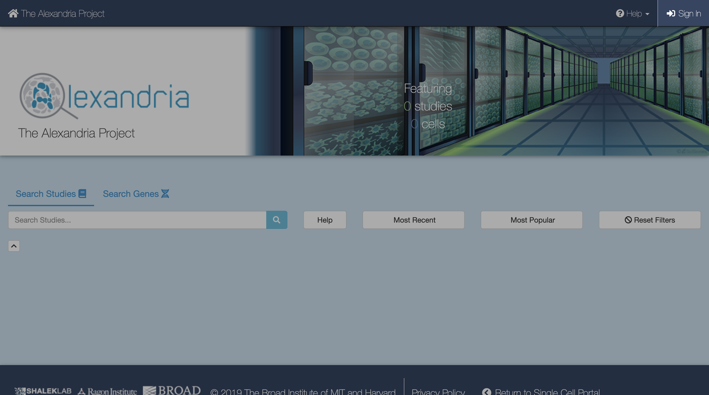

### 2. Create a New Study

To create a new study, click Add a Study. Alternatively, to run the workflow on a pre-existing study, select “My Studies”, click the Upload/Edit Study button for your study of choice and proceed to upload your sequence data files. 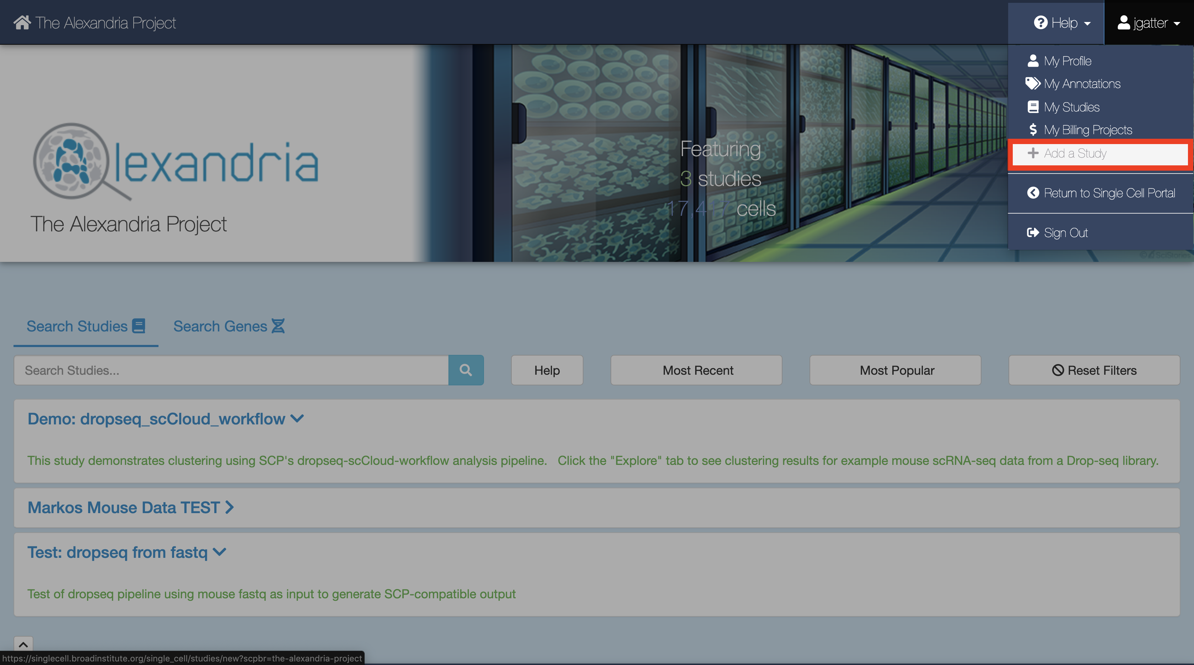 When you arrive at the New Study page, first enter the name that you and others will use to identify your study.

Then, use the FireCloud Billing Project dropdown menu to select a billing project other than Default Project in order to run workflows in your study. If you do not have a billing project associated with your account, first click the “create a billing project” hyperlink under the Billing Projects header, on the next page click New Billing Project, and then follow the instructions supplied by clicking the [“Instructions on creating Google billing accounts”](https://software.broadinstitute.org/firecloud/documentation/article?id=9762) button.

Next, fill out other fields to your liking, including the “No Data Download Until?” box, the “Public” dropdown menu, the “Use an existing workspace?” dropdown menu, and the “Description” box. 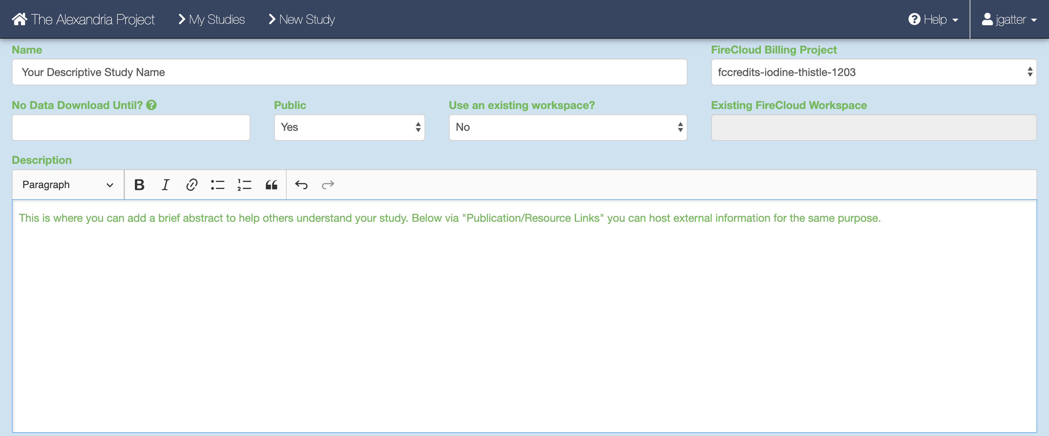. To share your study with others, click the “Share Study” button for however people as you wish to share your study with and then enter in their respective emails and permissions.

Attach external resources or publications that will help viewers understand your study using the “Add an External Resource” button for however documents you wish to share.  
When all fields are filled in to your satisfaction, click the “Create Study” at the bottom. 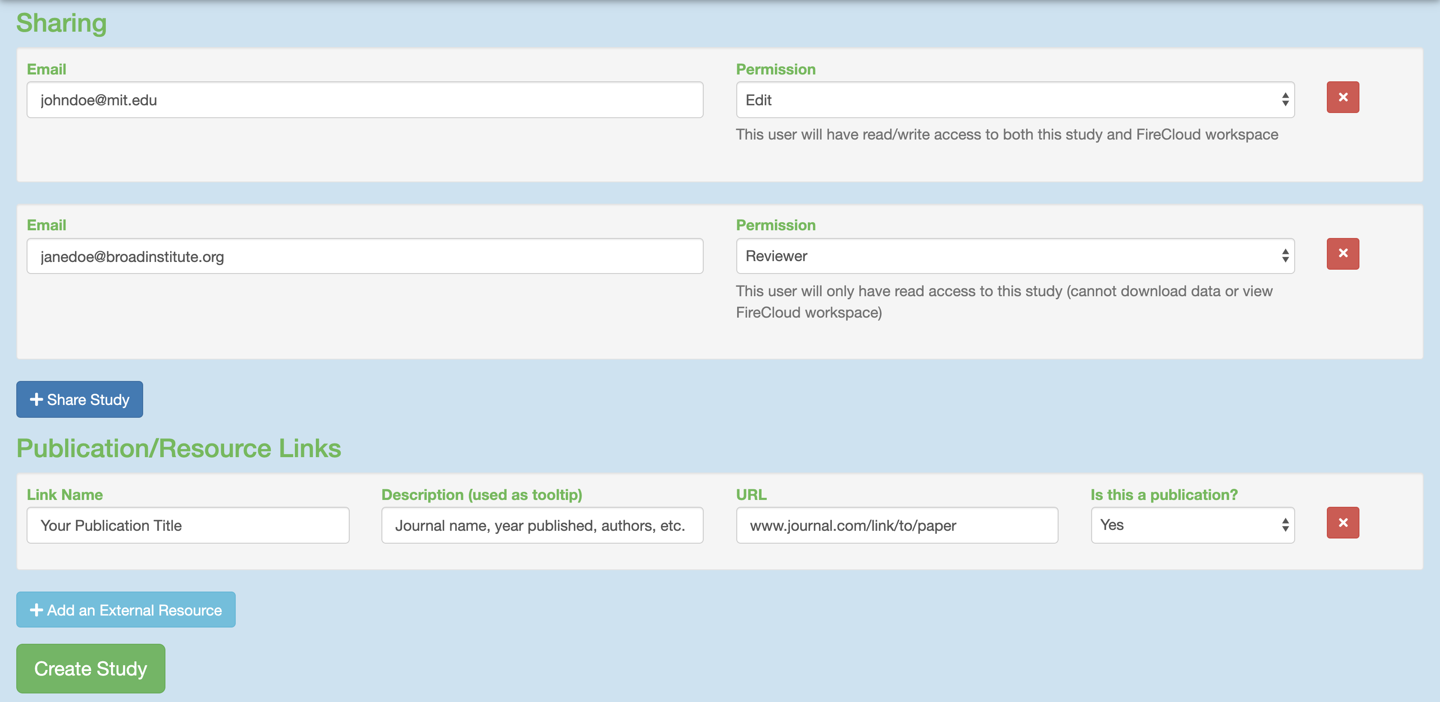

### 3. Uploading Sequence Data Files

When the study is created you will arrive at the Upload/Edit Study page. Since we are running the workflow and do not have any expression matrix, metadata, cluster, or coordinate label files yet (these will be produced by the workflow), click the “Sequence Data” tab. 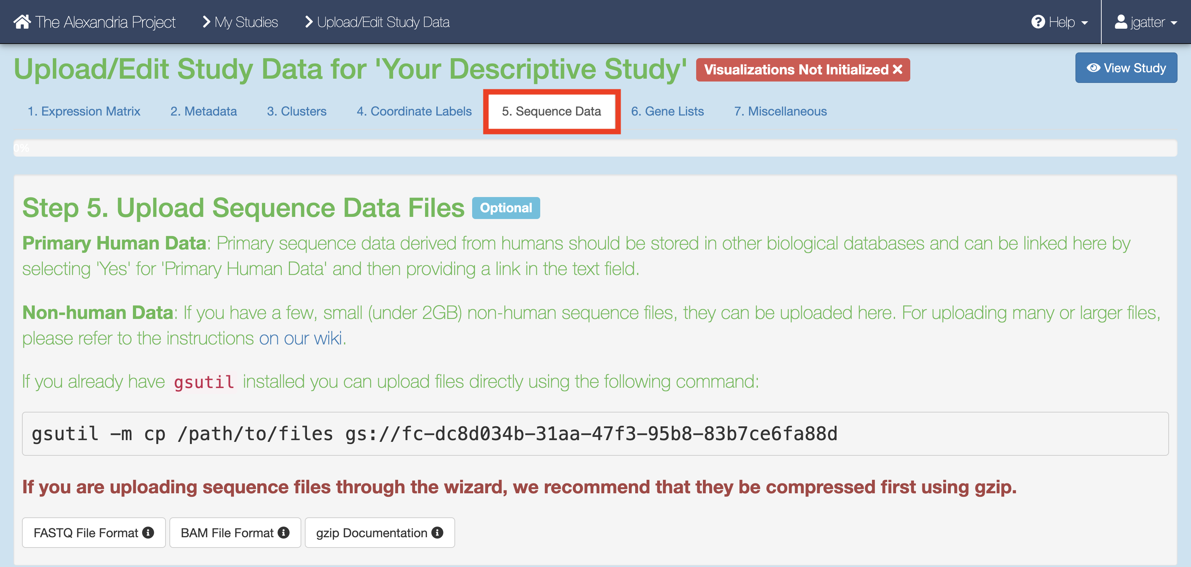

There are three methods of uploading sequence data. Proceed to the next step after completing one of the following:

1. gsutil **HIGHLY RECOMMENDED FOR ALL CASES:** If you have human data, data that is not a FASTQ, BAM, or gzip, or data that is larger than 2GB, you will need to use Google Cloud’s [gsutil tool](https://cloud.google.com/storage/docs/gsutil) through your computer’s console. You can follow Single Cell Portal’s instructions on [how to upload files via gsutil](https://github.com/broadinstitute/single_cell_portal/wiki/Uploading-Files-Using-Gsutil-Tool). It’s super fast and not too hard to get the hang of!  
   An example command that would transfer files from your computer to the workspace bucket would be:  
   gsutil -m cp local/path/to/file.fastq.gz gs://[Bucket ID]/destination/directory/  
   For an entire folder of sequence data, copy it recursively through using the command as such:  
   gsutil -m cp -r local/path/to/folder gs://[Bucket ID]/destination/directory
2. If you are looking for something simpler and have non-human FASTQ, BAM, or gzip files that under 2GB, look at the blue fields below. You can upload a file by clicking the “Upload Data File” button and navigating to the file of interest. Once done, enter the name, description, File type, species, whether the data is human or not, and then click “Upload & Save File” and “Save”. To add more files that match this criteria, click “Add a Primary Data File” and repeat the process. 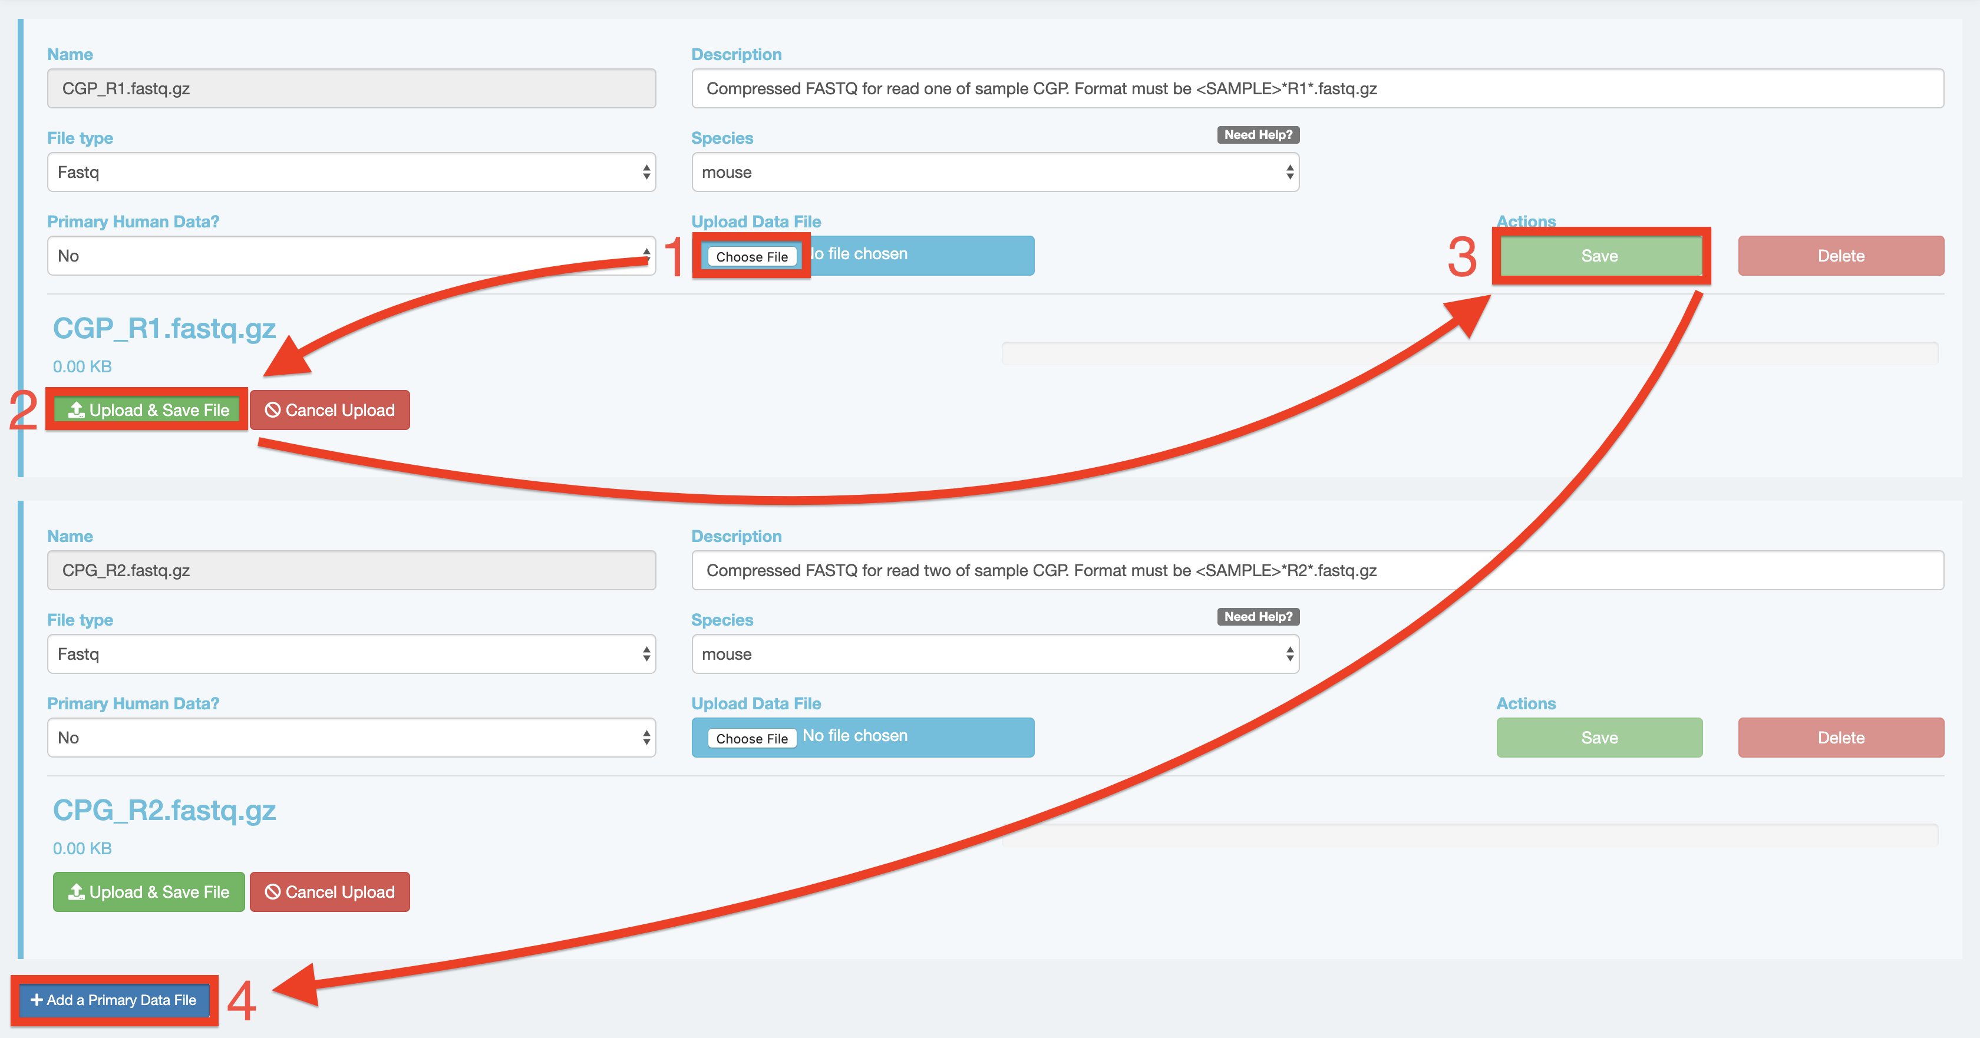
3. A third option is visiting the study’s Google Bucket and manually uploading files, but note that this takes a considerable amount of time! Return to “My Studies” through the top-right dropdown menu that has your account name and select the “Show Details” button for your study. On the the details page, scroll down and click the “View Google Bucket” button that is next to the Google Storage Bucket ID. 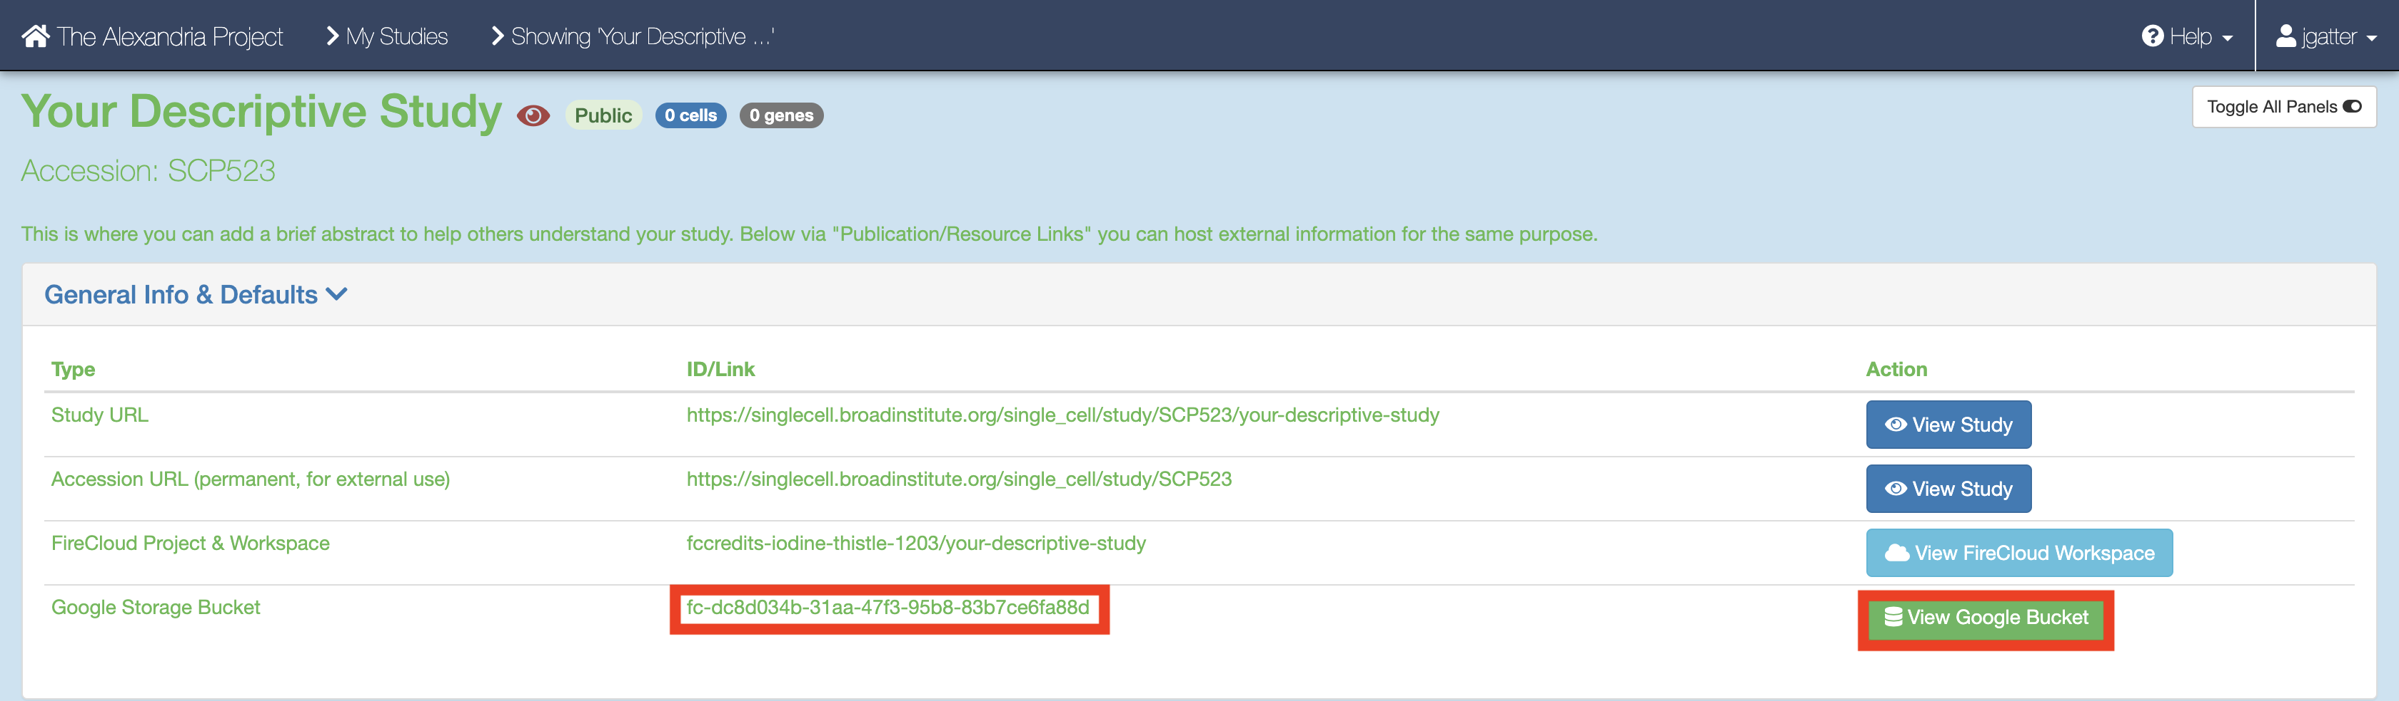 This button brings you to the Google Cloud Bucket associated with you study which is where all study files are uploaded. Click either the “Upload File” or “Upload Folder” button to navigate to and upload your files or a folder containing your files respectively. Return to your “My Studies” page and hit the “Upload/Edit Data” button for your study to upload the input CSV. 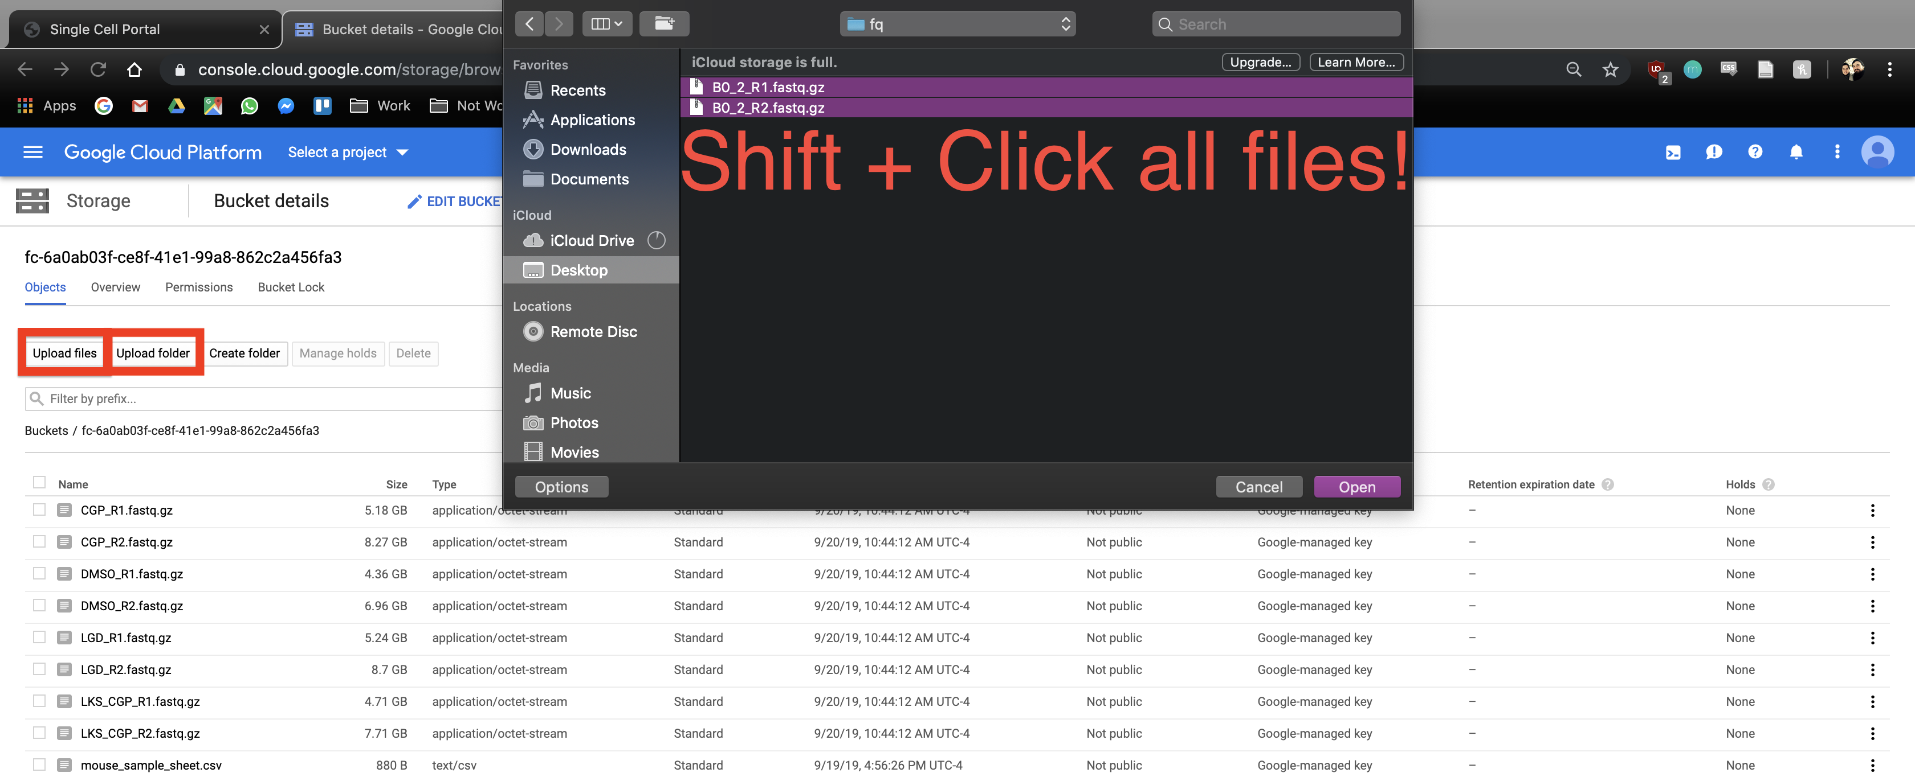.

### 4. Uploading Your Input CSV File

When you have finished uploading your sequencing data, proceed to the “Miscellaneous” tab. Here is where you will upload your input_CSV_file (spreadsheet) that will instruct the workflow.

Before uploading your input CSV file, it is recommended that you make certain that it adheres to the criteria specified in the documentation. To verify that the paths you listed in the file are correct, navigate to your bucket using the instructions listed above and locate your sequence data files. Click on each file to view its URI (gsURL), which should resemble the format gs://<bucket ID>/path/to/file.fastq.gz in the case of gzip-compressed FASTQ files. The locations you should enter in the path columns of your input CSV file should be all of the characters following the bucket ID and trailing slash, in this case path/to/file.fastq.gz. 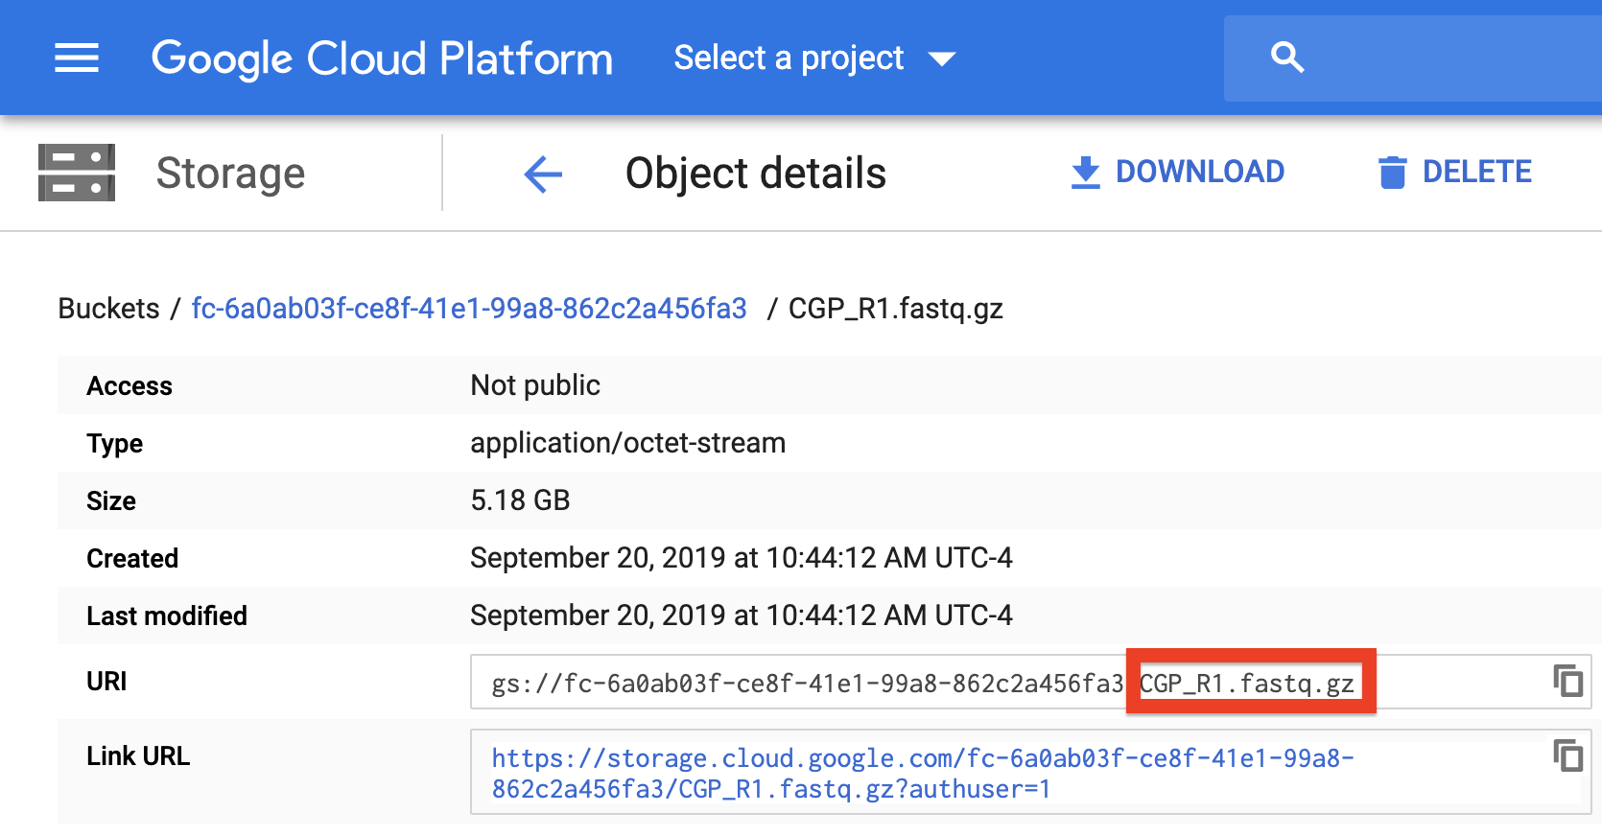

To upload the input CSV file, click the “Choose File” button and navigate to select your input CSV file. Then set the file type as “Other” and click “Save” under the “Actions” text. 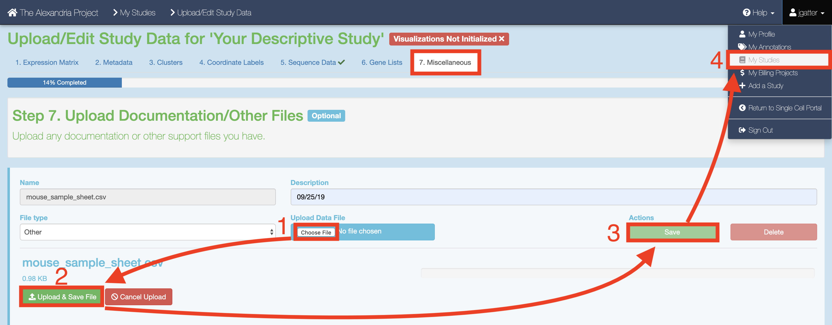

### 5. Configure and Launch dropseq_scCloud

**To ensure that your study recognizes all files, return to your “My Studies” page and hit the “Synchronize” button for your study.**

On the “My Studies” page, click the name of your study hyperlink. Next, visit the “Analysis” tab which contains your “Submission History” and the interface that allows you to “Submit a Workflow.”

By default you are on the “Select Workflow” tab. Use the dropdown menu to select the dropseq_scCloud workflow. 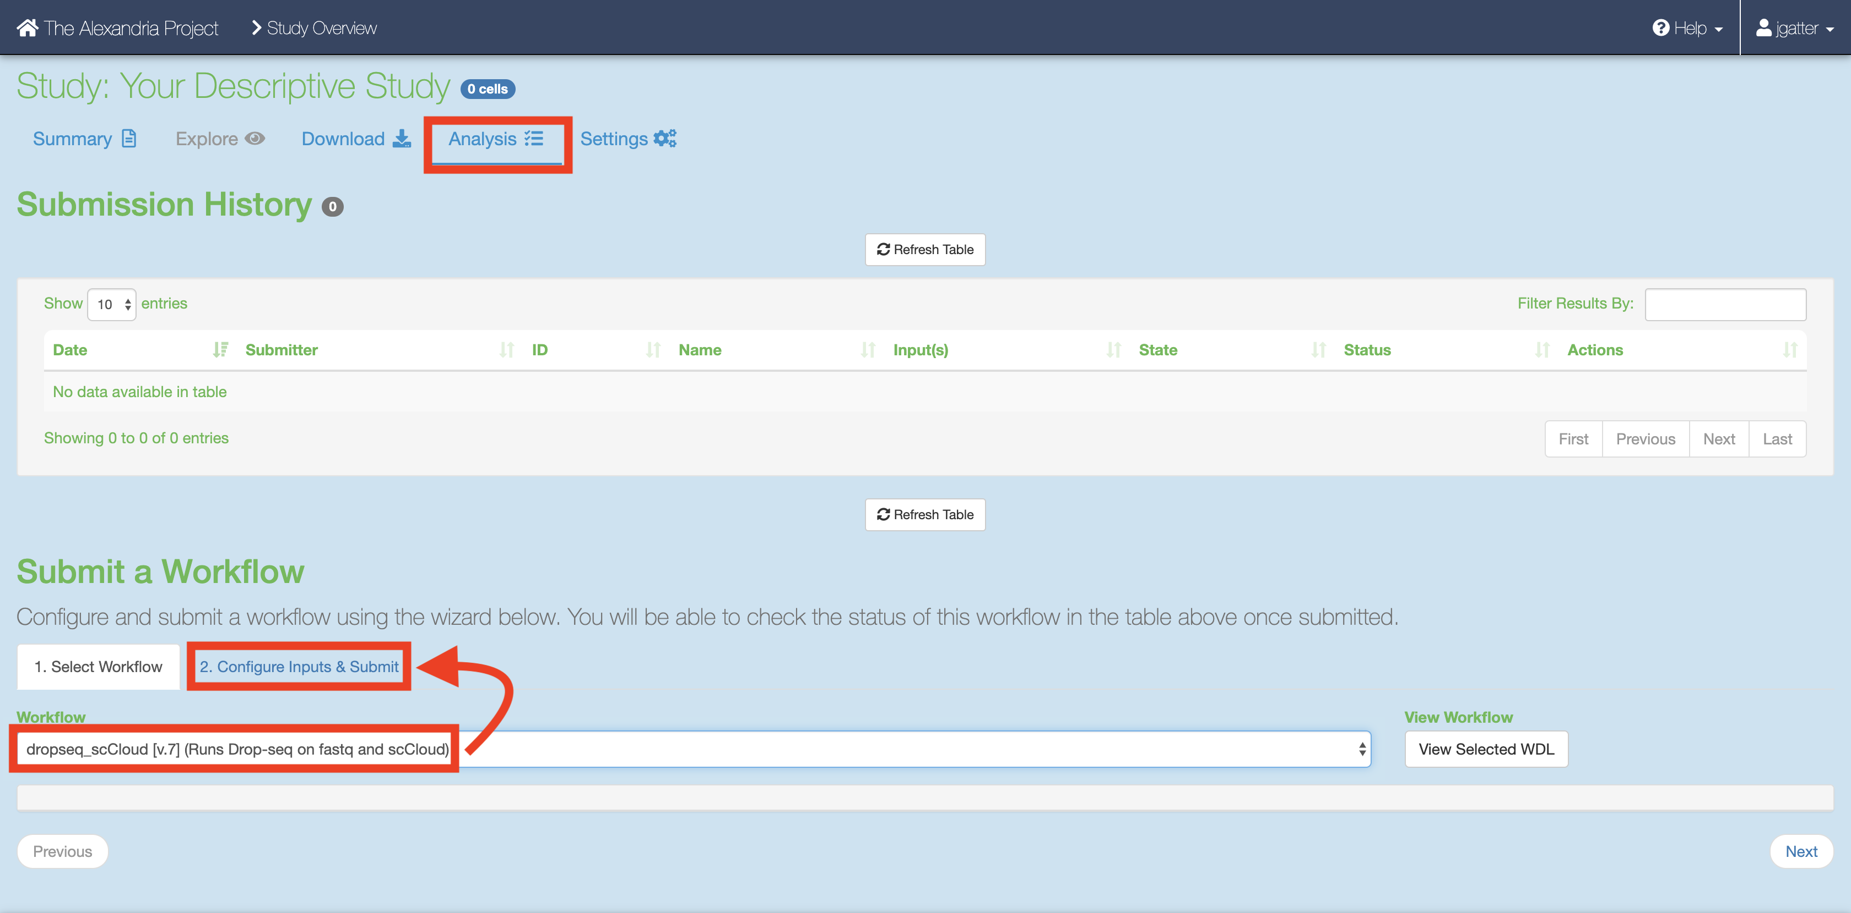 Then, click on the “Configure Inputs & Submit” tab. Read the table of parameters below and enter the fields for each parameter to your liking. 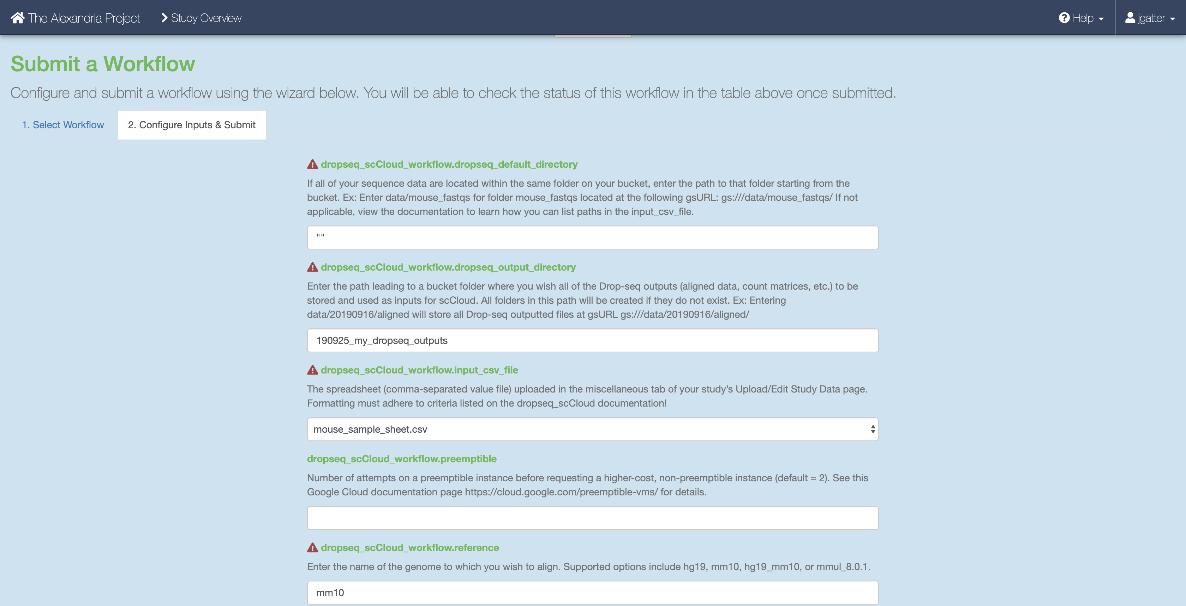

Once done, click the “Submit Workflow” button at the bottom to submit the dropseq_scCloud job. Your job is viewable up top underneath the “Submission History” header. 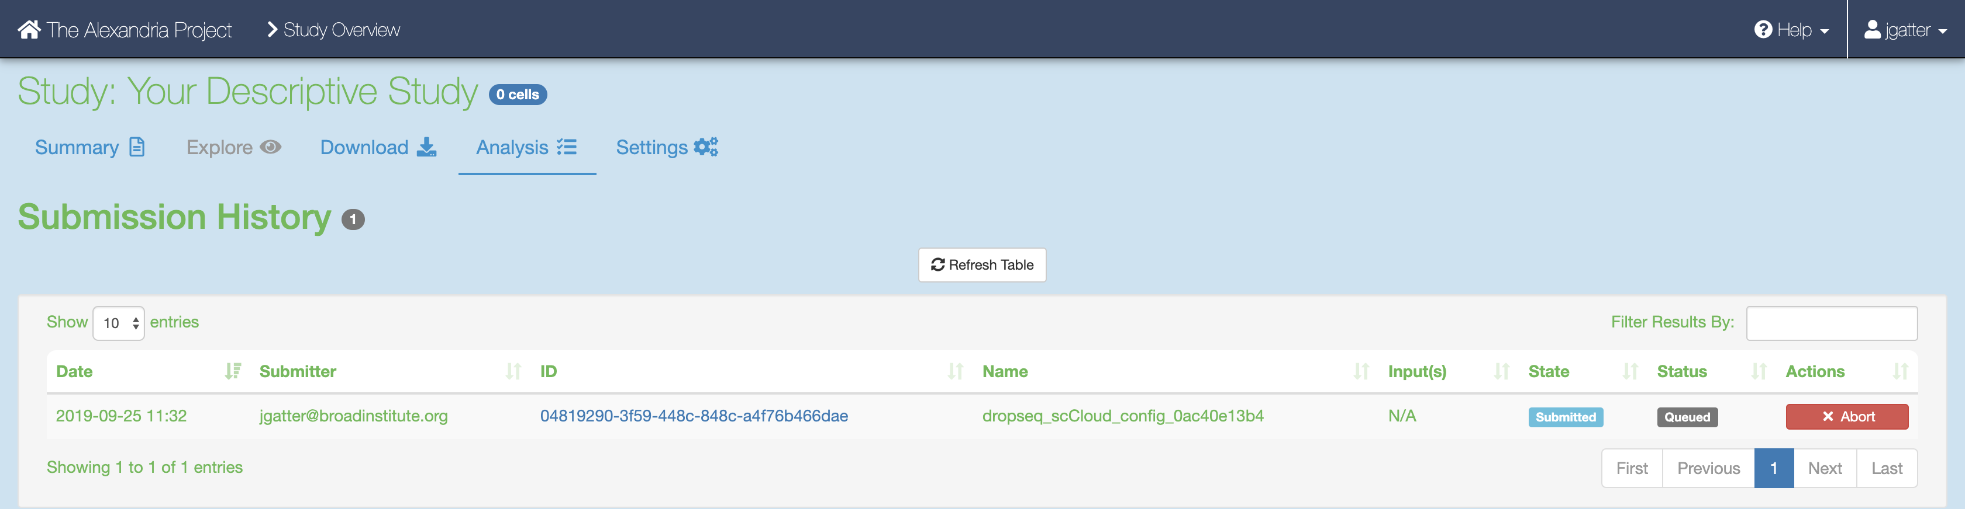

Here you will eventually know if the job ran succesfully. Provided the job does not fail within 10 minutes, the job will take about a variable amount of time to complete depending on the tasks you are running and the amount of data you gave it. Drop-seq pipeline usually will take 20 to 45 hours to run while scCloud should take an hour or less.

### 6. Advice for Troubleshooting on Alexandria/SCP

If the job fails it is recommended you navigate to and read the log file of the task that failed.  
To do this, click the Link URL of the failed job. 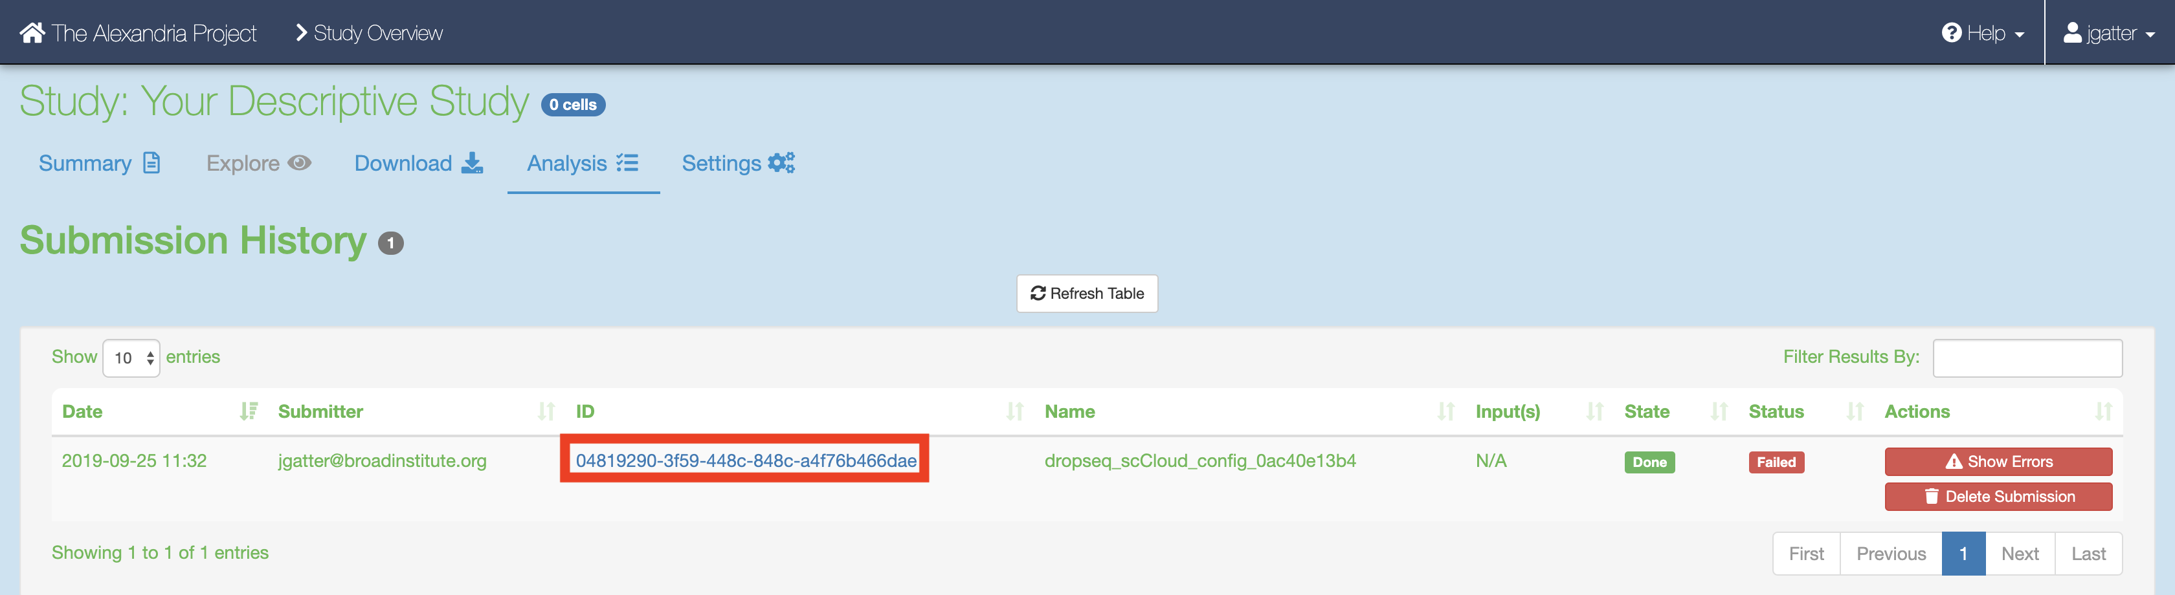

Navigate to the log file of the failed task, which in this case is setup_dropseq. 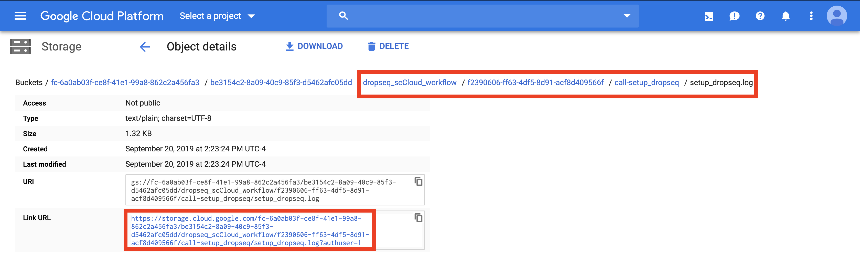

Evaluate the error based on the message and decide whether you need to alter variables, move files in your bucket, or change and reupload your input CSV file.

**Make sure to synchronize your study before relaunching the job.**

### 7. Synchronizing and Exploring Visualization Options

If you study ran through the scCloud task successfully: Synchronize your the outputs by clicking the “Sync” button in the “Analysis” tab. 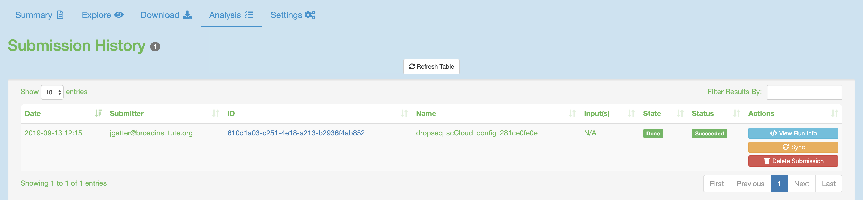 Visualize the study by clicking the “Explore” tab and then the “View Options” hyperlink to gain more options for analysis. 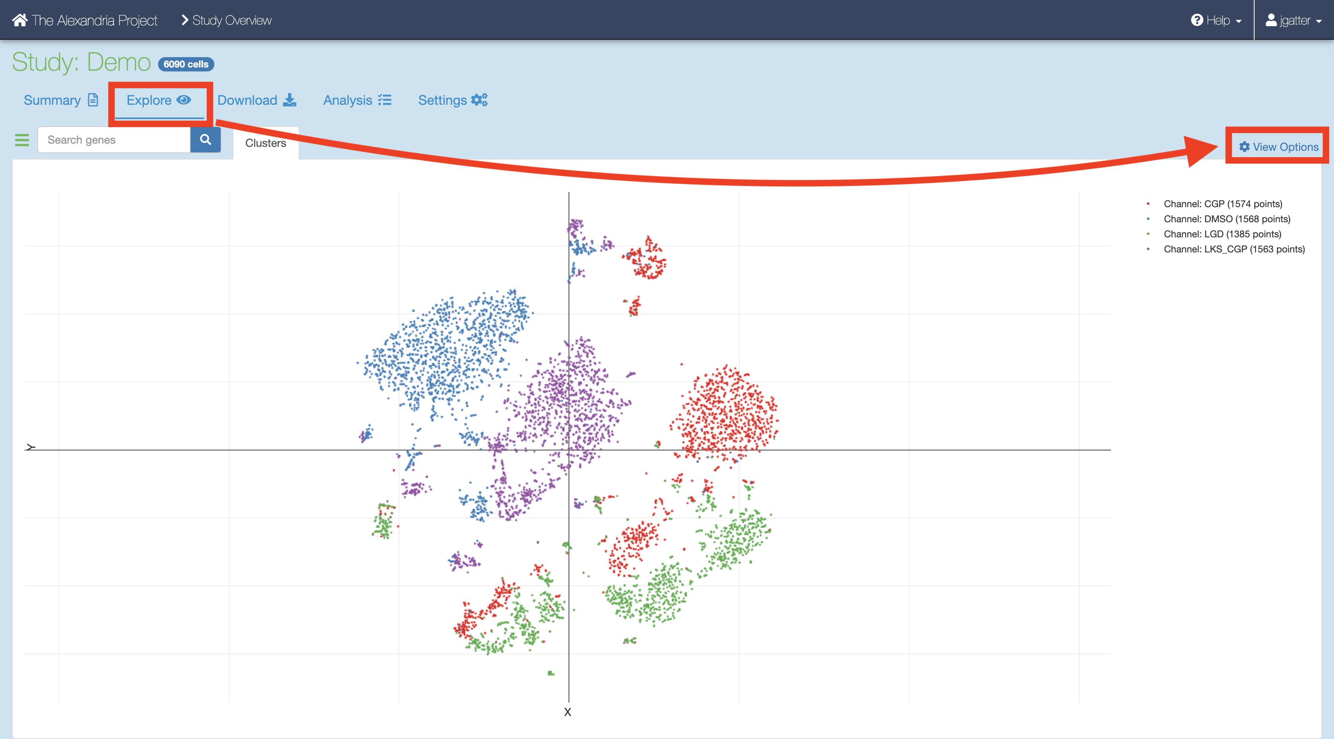 #

Running dropseq_scCloud_workflow on Terra

The Terra version of the workflow has gives the user access to all workflow parameters as it is intended for users with advanced knowledge of the single-cell field.

### KNOWN BUGS IN SNAPSHOT 74:

* Do not upload sequence files into the root of the bucket, instead use gsutil to move them into a folder on your bucket. Example: gsutil -m cp -r local/mouse_fastqs gs://[bucket ID]/mouse_fastqs. gsutil -m mv gs://[bucket ID]/*.fastq.gz gs://[bucket ID]/mouse_fastqs can be used to move all FASTQs already on the bucket to a directory mouse_fastqs that will be automatically created.
* is_bcl=true/run_bcl2fastq=true is broken due to regevlab changing their docker repo for the tool.

### 1. Sign In

Visit the Terra by the Broad Institute and sign in using your preferred Google email account and complete the user profile registration steps if it is your first time using Terra. 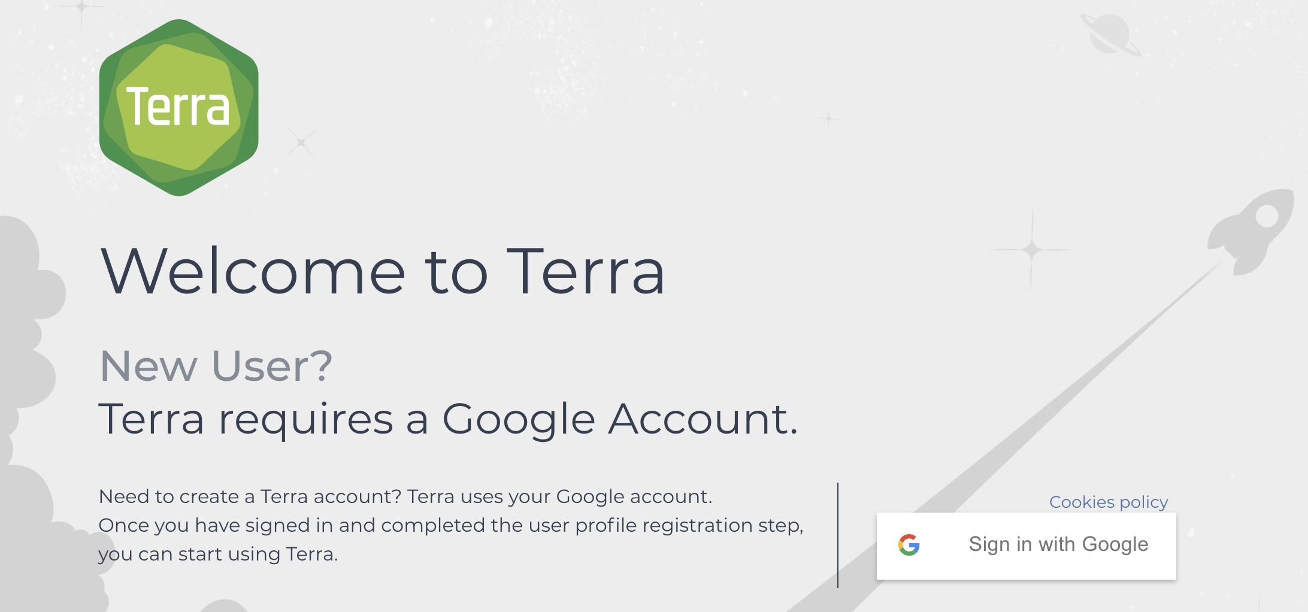

### 2. Create a New Workspace.

Skip this step if you have an existing workspace where you would like run dropseq_scCloud.

After logging in/registration you will be brought to the “Your Workspaces” page, where you will see the "Create a New Workspace button. Click it and fill out the fields to your liking. 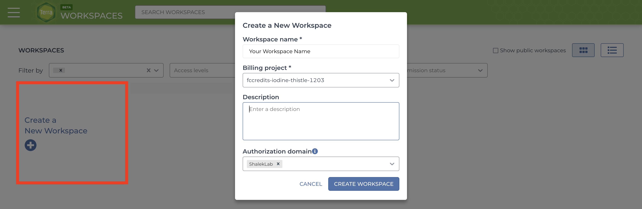

If you do not have a billing group, look [into creating a billing account](https://software.broadinstitute.org/firecloud/documentation/article?id=9762).

The authorization domain] is the group of users who will be able to access your workspace. You can create an authorization domain by following the instructions [here](https://support.terra.bio/hc/en-us/articles/360026775691).

### 3. Add Your Sequence Data and Input CSV File

There are three methods of uploading files to your workspace Google Bucket. Before proceeding, find your workspace bucket by visiting your workspace’s “Dashboard” tab. In the bottom-right corner of the dashboard, you will see your Google Bucket ID which you can copy by clicking the adjacent clipboard button. You can visit the bucket interface by clicking the “Open in Browser” hyperlink.

First upload your sequence data files using one of the methods below.

1. gsutil **HIGHLY RECOMMENDED**: Through your computer’s console, install the gsutil tool by following the [installation guide](https://cloud.google.com/storage/docs/gsutil_install). An example command that would transfer files from your computer to the workspace bucket would be:  
   gsutil -m cp local/path/to/file.fastq.gz gs://[Bucket ID]/destination/directory/  
   For an entire folder of sequence data, copy it recursively through using the command as such:  
   gsutil -m cp -r local/path/to/folder gs://[Bucket ID]/destination/directory.
2. You can also manually upload data to the Google Bucket, but note that this process take much more time than gsutil. At the bottom right of your workspace’s “Dashboard” tab, click the “Open in Browser” hyperlink to visit your bucket. Click either the “Upload File” or “Upload Folder” button to navigate to and upload your files or a folder containing your files respectively. 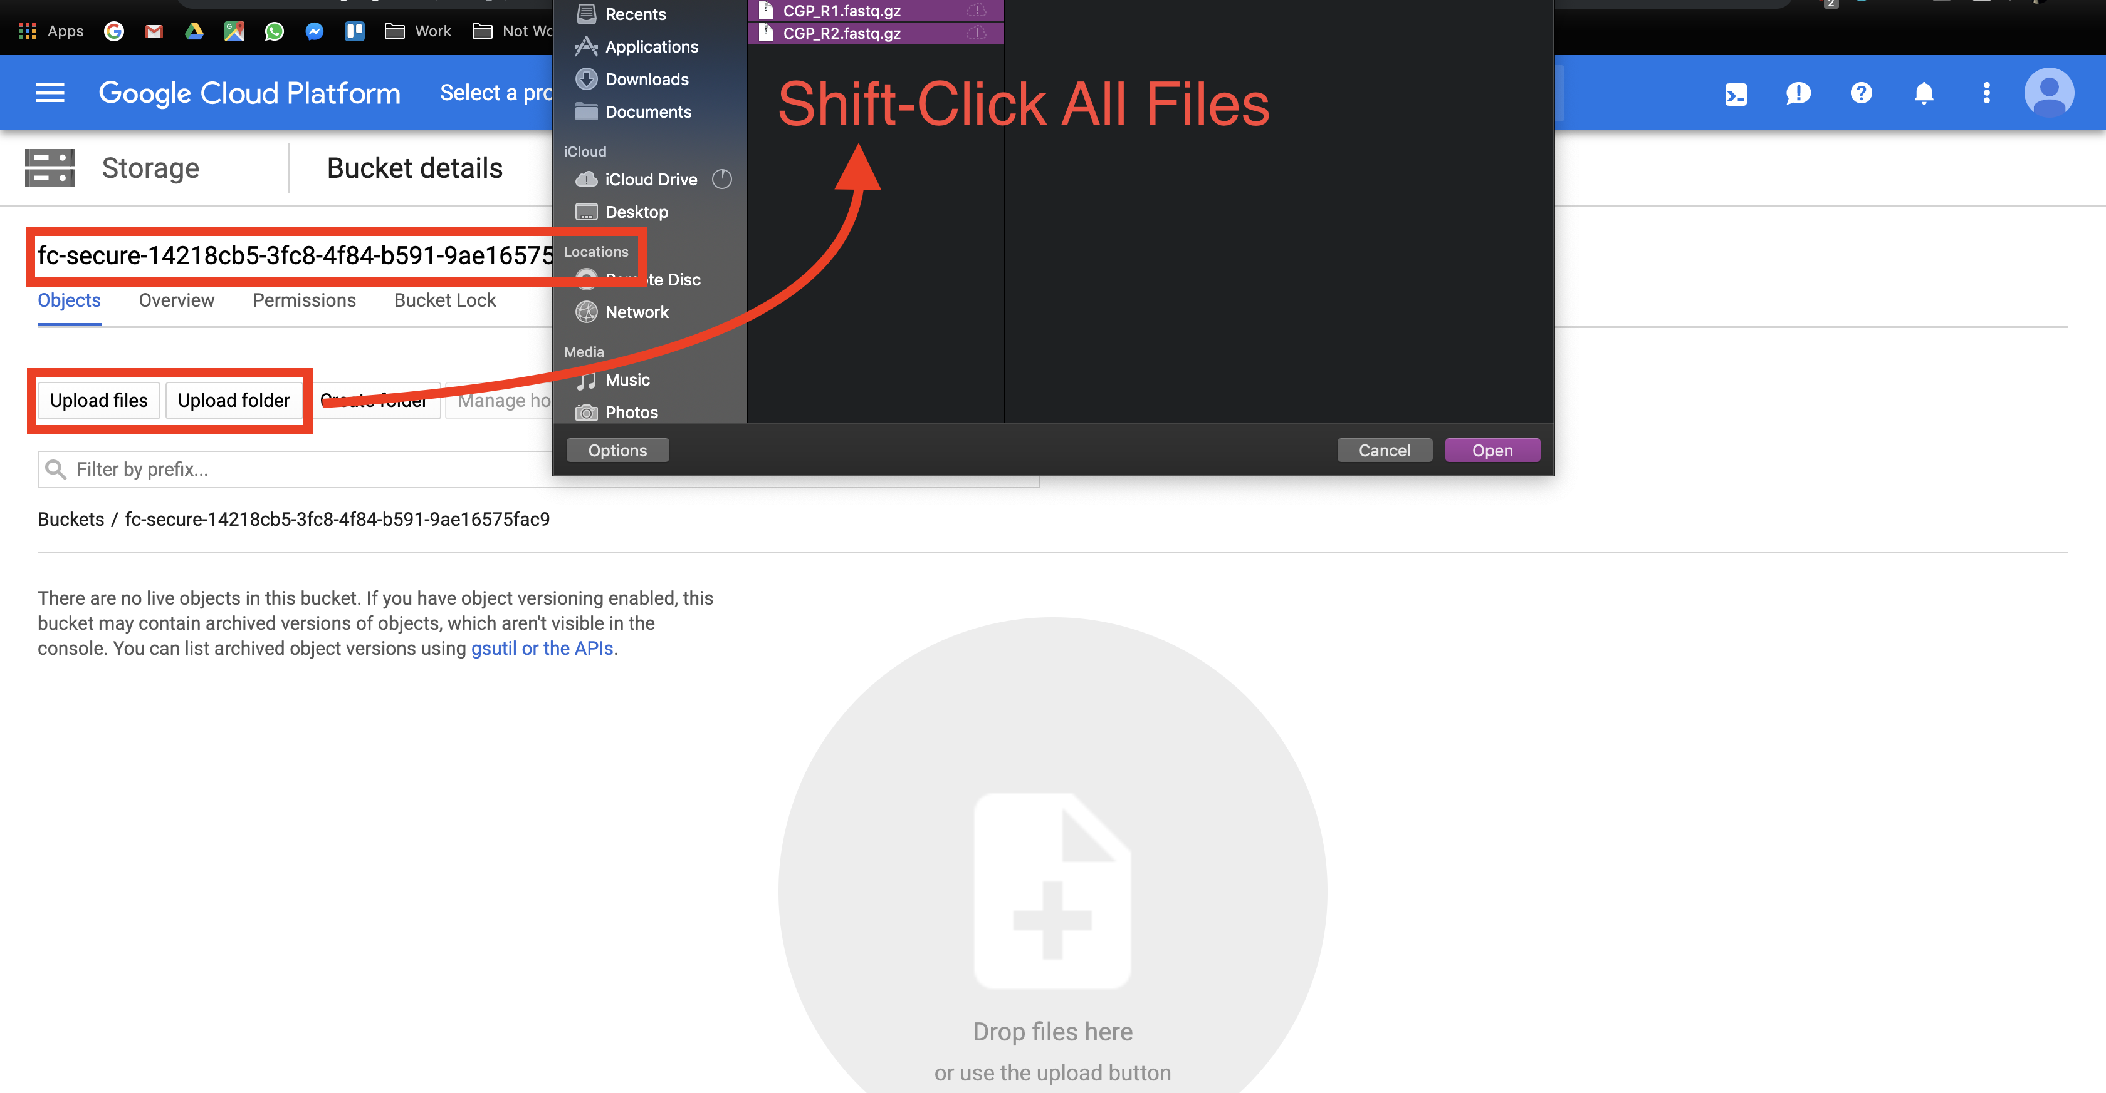
3. Alternatively to gsutil and Google Bucket file uploading, users can manually upload data one file at a time through the Terra interface. This method is painfully slow so you should strongly consider using gsutil. Go to the “Data” tab and click the plus button towards the bottom-right of the page. Navigate to and select your file and hit open. Repeat the process for however many files. 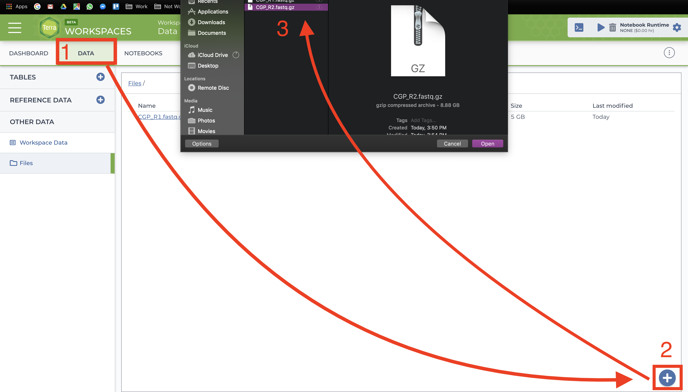

Before uploading your input CSV file, it is recommended that you make certain that it adheres to the criteria specified in the documentation. To verify that the paths you listed in the file are correct, navigate to your bucket using the instructions listed above and locate your sequence data files. Click on each file to view its URI (gsURL), which should resemble the format gs://<bucket ID>/path/to/file.fastq.gz in the case of gzip-compressed FASTQ files. The locations you should enter in the path columns of your input CSV file should be all of the characters following the bucket ID and trailing slash, in this case path/to/file.fastq.gz. 

When finished, upload your input CSV file to the bucket.

### 4. Import the dropseq_scCloud Workflow

This section may be subject to change in the recent future as Terra is still undergoing development and soon Firecloud Methods will be integrated to Terra rather than remain in the legacy application.

To import workflows for running jobs in your workspace, click the “Workflow” tab and click the “Find a Workflow” button. On the window that pops up, click the “Broad Method Repository” hyperlink to be brought to FireCloud Methods. 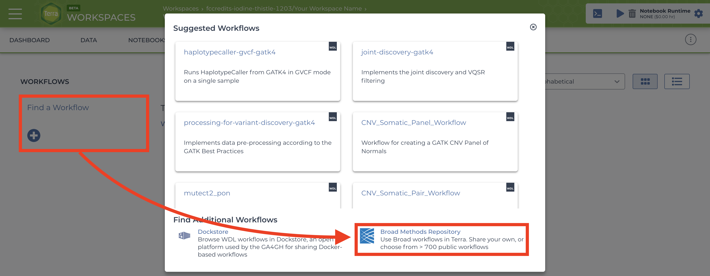.

In the search bar, enter “dropseq_scCloud_workflow”, hit search, and click on the dropseq_scCloud_workflow hyperlink when it appears. 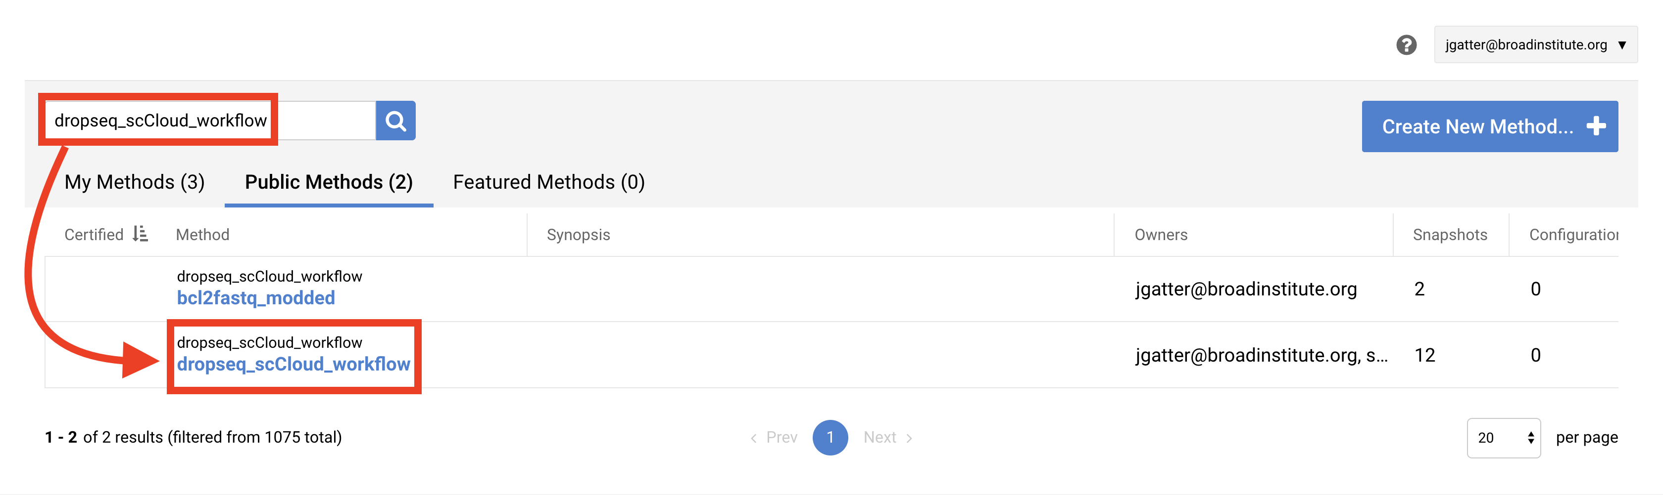.

Towards the top-right of the workflow page, click “Export to Workspace…” button and then click the “Use Blank Configuration” button. Select your workspace as the destination workspace via the bottom-most dropdown menu. Click the “Export to Workspace” button and when it offers you to visit the edit page, click “Yes”. 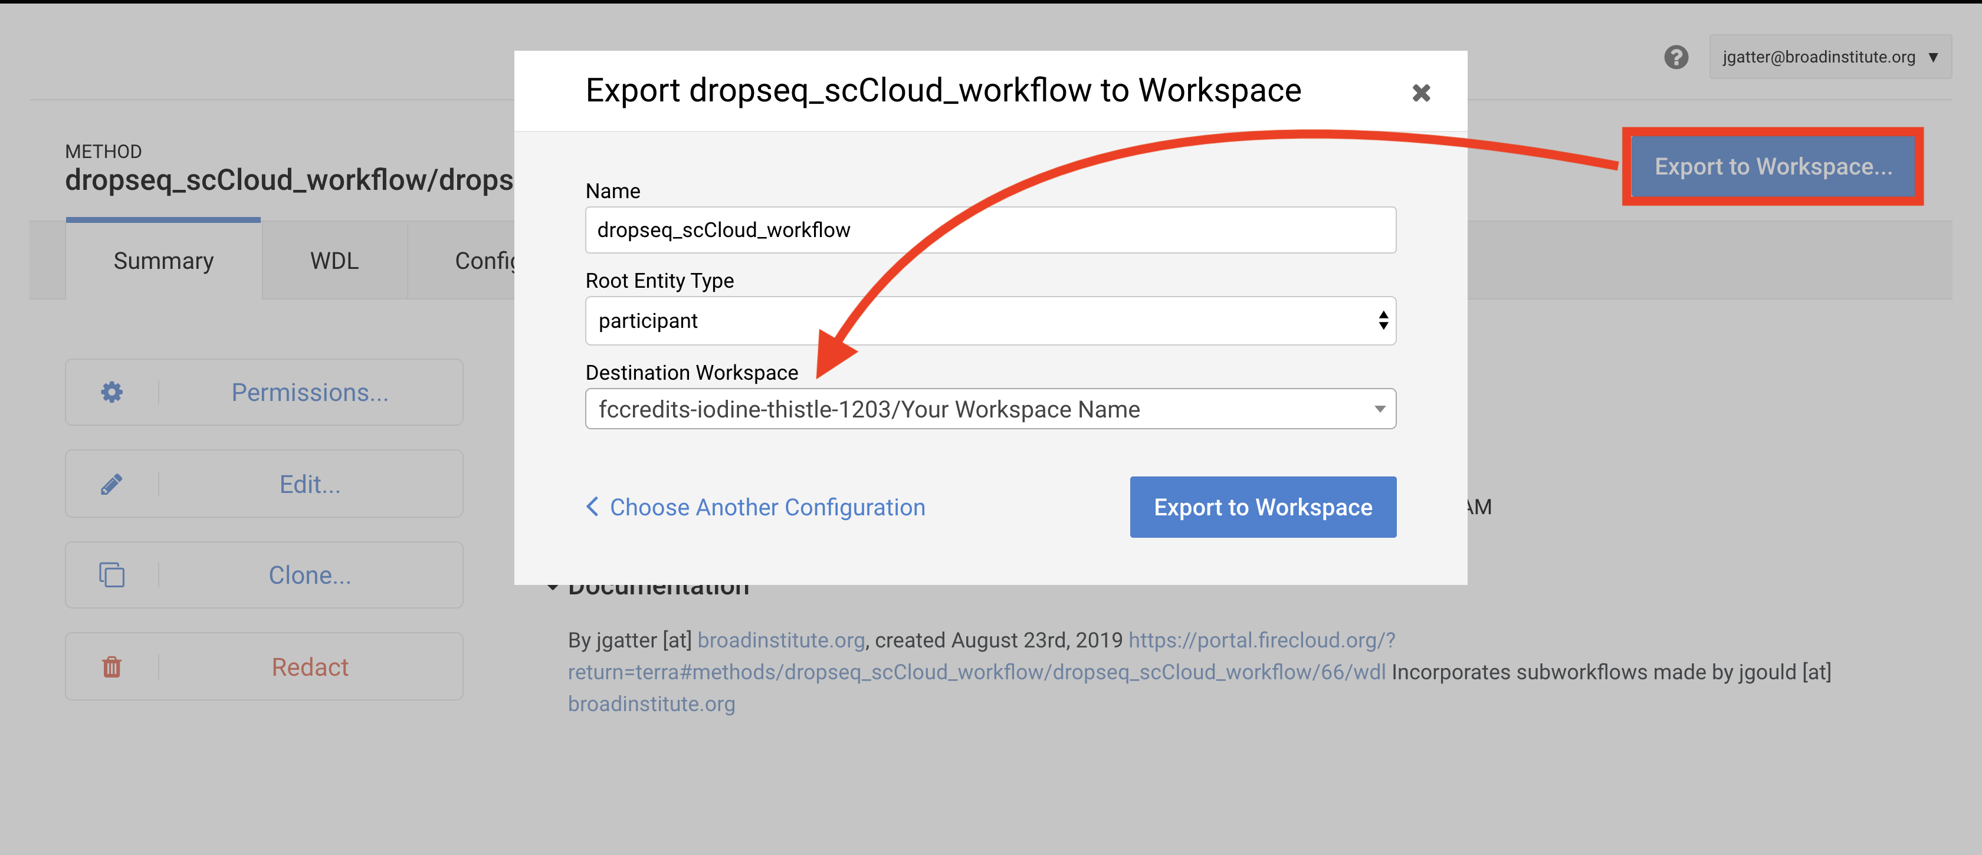

### 5. Configure and Launch dropseq_scCloud_workflow

You should be on the edit page of the tool now, but to access this page of the tool in the future, you can go to the Workflow tab of your Terra Workspace and click on the dropseq_scCloud_workflow button.

This page is where you set variables for dropseq_scCloud_workflow, Drop-seq pipeline workflow, and scCloud workflow. First click the bubble for “Process single workflow from files.” Scroll down to fill out required inputs. Note that Strings must be surrounded by quotation marks and typing true and false (don’t surround with quotation marks) for Booleans are case-sensitive. 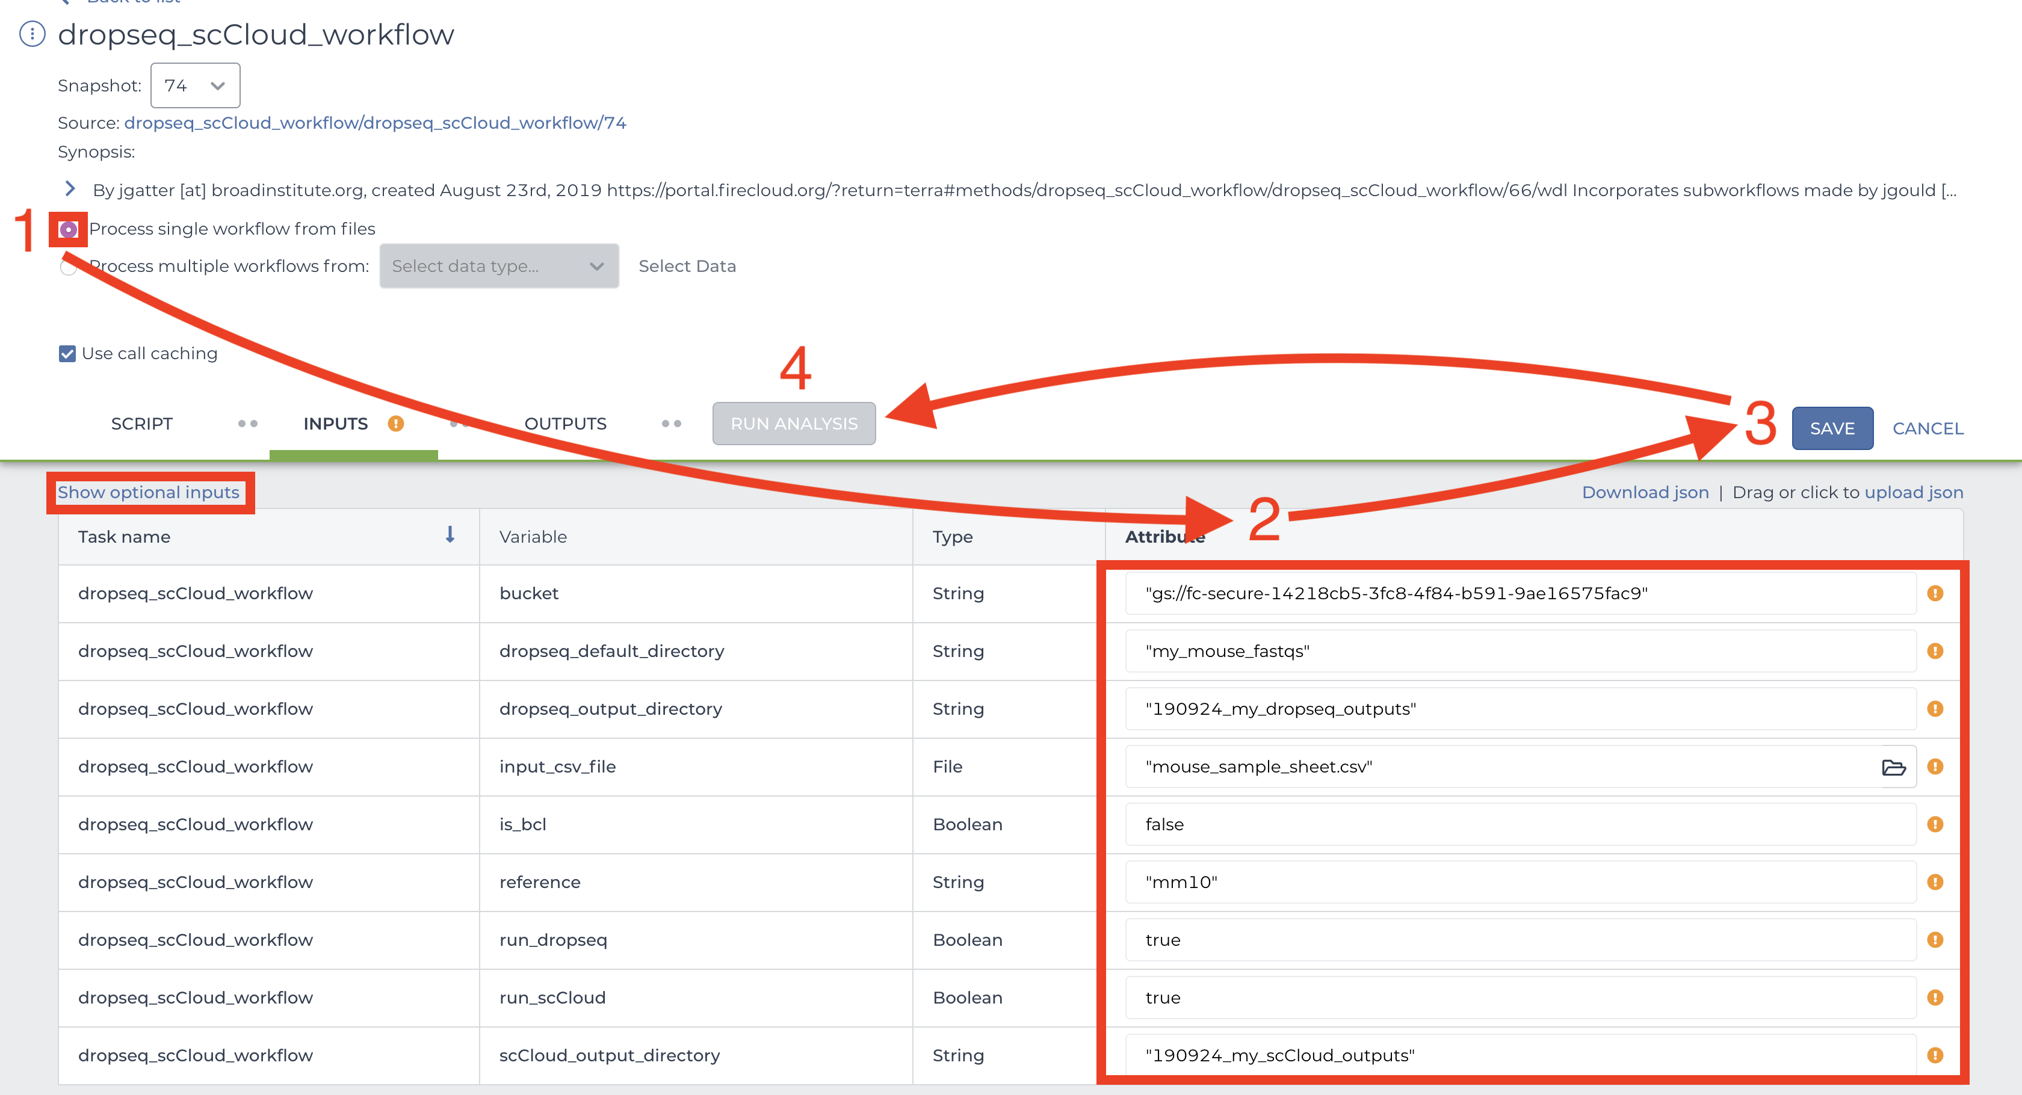

To set values for optional parameters, click the “Show optional inputs” text above the “Task name” column and scroll down. These are variables that have default values if the boxes are left empty, so there is no need to fill each out unless it suits your needs. To better understand the “dropseq” and “scCloud” inputs, read the [Drop-seq pipeline](https://sccloud.readthedocs.io/en/latest/drop_seq.html#inputs) and [scCloud](https://sccloud.readthedocs.io/en/latest/scCloud.html#aggregate-matrix) documentations. It should be mentioned that each workflow’s required inputs have been overridden by dropseq_scCloud workflow (e.g. input_csv_file, output_directory, etc.), so refer to the dropseq_scCloud documentation for those related variables.

When satisfied with your inputs, save them using the button in the upper-right and and then hit the “RUN ANALYSIS” button to the left. You will be brought to the job history page where your job has been logged. Here you will eventually know if the job ran succesfully. Provided the job does not fail within 10 minutes, the job will take about a variable amount of time to complete depending on the tasks you are running and the amount of data you gave it. Drop-seq pipeline usually will take 20 to 45 hours to run while scCloud should take an hour or less.

### 6. Advice for Troubleshooting

If the job fails it is recommended you navigate to and read the log file of the task that failed.  
To do this, click the failed job in “Job History” tab and click “View” on the next page. Then on the workflow status page under the “List View” tab, click the hyperlink of the failed task and repeat if there are failed subtasks. On the failed subtask that has no children, click on the log file button and skim to gain a better understanding. 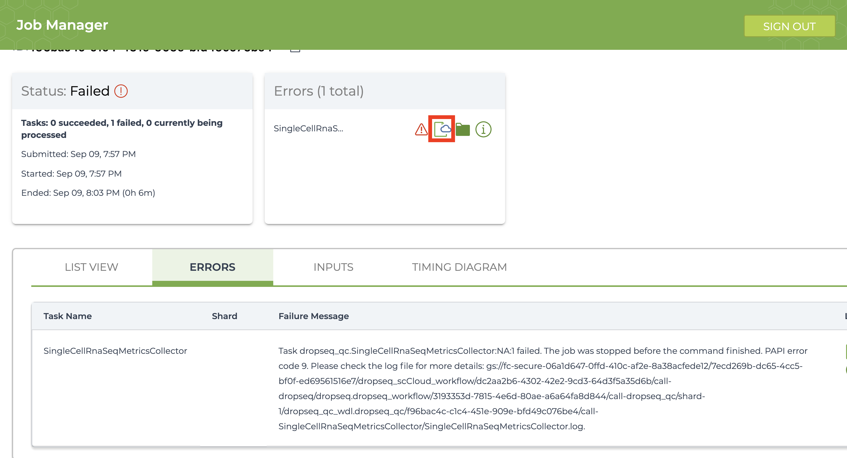

Evaluate the error based on the message and decide whether you need to alter variables, move files in your bucket, or change and reupload your input CSV file.

### 7. Uploading scCloud Output Files to Alexandria for Visualization

The explicit workflow outputs of dropseq_scCloud_workflow are the alexandria metadata file (alexandria_metadata.txt), the dense expression matrix (ends with .scp.expr.txt), and the two coordinate files (end with .scp.X_diffmap_pca.coords.txt and .scp.X_fitsne.coords.txt). Download these to your computer by visiting your Google Bucket through the workspace dashboard and then reupload via the first four tabs of the Upload/Edit Study page of the Alexandria workspace (See Running dropseq_scCloud on the Alexandria for a better understanding). Alternatively, use gsutil to transfer the files from your Terra bucket to your Alexandria bucket

Synchronize your Single Cell Portal study to account for the added files. Visualize the study by clicking the “Explore” tab and then the “View Options” hyperlink to gain more options for analysis. 